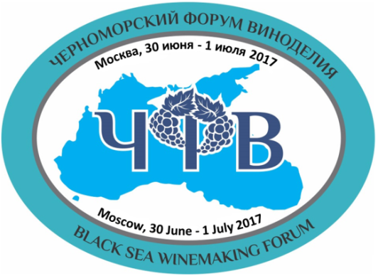 | Black Sea Winemaking Forum  32, Dmitriya Ulianova st., 117036, Moscow, Russia  Tel.:+7 (495) 968-26-51, e-mail: blackseawinemaking@gmail.com  www.blackseawine.ru  “Black Sea Wines”/ “Вина Черного Моря”  Competition and Rating 2017/  Конкурс и рейтинг 2017
Registration Form

- Name of Wine or Spirituos Beverge of Vitivinicultural Origin
- Name of Company
- Type of Wine or Spirituos Beverge of Vitivinicultural Origin  (please choose from the list) | Wine-Still-Red; Wine-Still-White; Wine-Still-Rose  Wine-Sparkling-Red; Wine-Sparkling-White  Wine-Sparkling-Rose  Wine-Liqueur Wine-White; Wine- Liqueur Wine-Red  Wine- Liqueur Wine-Rose  Brandy (Divin, Metaxa, Pliska), Chacha,Palinka, Rakija  Other Spirituous Beverage of Vitivinicultural Origin (please specify)
- Country
- Region
- Appellation
(if known)
- Varietals
(% of each if known)
- Vintage
- AlcoholbyVolume
(%vol)
- OakedWine | Yes/No
- OrganicWine | Yes/No
- Flavour Profile  (please choose from the list) | Dry;Semi Dry; Semi Sweet; Sweet;Brut; Extra Brut, Other (please specify)
- Recommended Retail Price
in Euro (optional)
- Residual Sugar
(g/l)
- Total Acidity
(g/l)
- Type of Closure  (please choose from the list) | Natural Cork Closure, Twist &Plopp, Agglomerate CorkSynthetic Closure, Screw Cap, Other (please specify)
- Bottle Content  (please choosefrom the list) | 0.75; 0.375; 1.5,Other (please specify)
- EW Price
in Euro (optional)
- Volume of the Butch (in Bottels or in Litres)
- Basic Sales Channels  (optional) | Distributors, Cellar Door, Supermarkets, Big Retail Chains, Small and Medium Retail Stores Chains, Wine Boutiques, HoReCa, Internet, Other (please specify)  You can choose more than one
- Type of Company  (please choose from the list) | Producer, Dealer, Distributor, Other (please specify).  Companies (which just present the samples, but they are not producers of the presented sample) will need a written authorization from the actual producer
- Address
- Telephone
- E-mail
- Web Site
- Addresses in the Social Networks (optional)
- Name, Position in the Company, E-mail and Mobile Telephone of the Contact Person/Persons
Points 10-16 have to be filled only for wine samples
Please send this registration form together with the photo (HQ, but not heavier than 1 MB) of the sample presented for the competition and rating to the e-mail address: blackseawinemaking@gmail.com

